Little Cubs Childminding

Welcome Pack

C:\Users\McTe\AppData\Local\Microsoft\Windows\Temporary Internet Files\Content.IE5\HRVYR30O\MC900366338[1].wmf

***Information about who I am, the setting and what your child could be doing if you decide to use my services.***

My name is Jodie McTear and I would like to welcome you to my childminding services. I live with my Husband Aaron and our two children. We also have a cat called Jess.

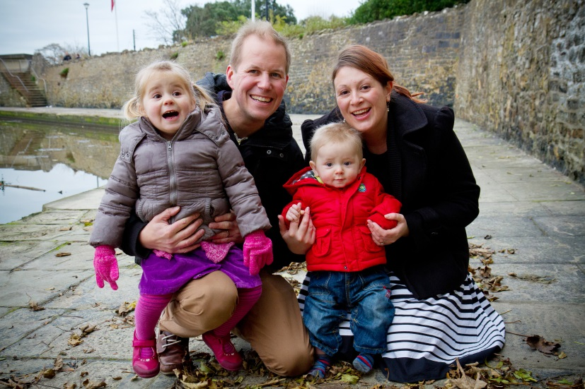

We live in Wotton-Under-Edge, we love living in here, despite only being here a couple of years!

I have primarily worked with children in a variety of jobs, including primary school teaching, teaching English in Japan, as well as childminding for the last 4 and ½ years. As well as work a lot of my experience has been gained from raising our two children.

I love working with children and enjoy watching them learn and grow. I have completed all my childminding qualifications; paediatric first aid, safeguarding and I continue to update my skills and knowledge. I’m currently studying a diploma in child psychology, and a unit on the importance of play.

I look forward to welcoming your child(ren) into my home and help them to develop and grow into happy, confident children, in a safe and caring environment.

**Our setting**We live in a 3 bedroom terraced house in the town of Wotton Under Edge. We have an enclosed private garden; we live near to the local park and are a short walk from the local primary school – The British School.

The children will have use of the following rooms:

* Living room/playroom – This is the main play room where we will play with toys, read books etc. Our dining table is also in this room, and is where we eat as well as do crafts,
* Garden – The children will have lots of play time in the garden, we have outdoor games and toys. We will be growing our own vegetables, and plants. We also have one of the local allotments, and it’s a great place to visit.
* Bedroom – for any younger children that may require it during the day for a nap.

Child led and free play is encouraged, we will have themes and activities throughout the year which the children will be encouraged to participate in should they wish to do so.

Use of the great outdoors is encouraged and I aim to get out and about daily and in all weathers.

**Communication - working in partnership with Parents**

It is crucial for the development of your child, that you and I work closely together and have excellent communication between us at all times. I have an 'open door' policy regarding communication.

I make time to talk with parents about their children and what we have been doing.  Parents are encouraged into my home, to look at artwork and planning which is displayed.  Parents are also encouraged to contribute to themes and quarterly newsletters if they wish.

If your child is feeling poorly, had any upset or issues the night before, or any other behaviour that is unusual please do confide occurrences with me so that I know what is going on in his/her life. I can then look after and support him/her accordingly in partnership with mum and dad.

Things I will need to know include:

* any allergies and/or medical conditions your child has
* foods that she/he particularly likes or dislikes
* favourite toys, comfort items, activities or books
* sleeping patterns

Please don't forget to mention anything that might affect your child's mood or behaviour, such as a bad night's sleep – please feel free to write this in the daily journal that comes home with your child(ren).

### General Communication

It is a good idea for us to chat regularly about the progress of your child but this isn't always possible every day. Your child's online daily diary is a useful tool for two-way communication. It is updated each day your child attends enabling us to share information and photos.

I use one for each child under school age to record mood, meals, snacks, drinks, toileting/nappy changes, sleep times, activities/toys played with, outings and any other important information to be shared for that day. I also share half-termly/termly their learning journey folder which has observation sheets with photographs for parents of their children so they can see all the fun and exciting activities we do!

Parents are encouraged to also add any information updates, requests, news or concerns they may have. I also provide ‘wow’ vouchers for parents to share any special moments or achievements with us, and these will be celebrated with the child and put in their learning journal.

School aged children have their own child folder and this is used for newsletters, artwork etc. and records meals/snacks and activities, along with any information needed to be shared from school. This way parents are kept fully informed regarding the care of their child.

**Hours and days**I will be open from 7.30am – 6.00pm Monday to Friday (hours outside of this may be accommodated)  
I will be closed some public and bank holidays and no charge will be made for those days I am unavailable to work. I will also be closed between Christmas and New Year.  
**Rates**£4.50 per hour, this will include drinks and snacks. It is an extra £2 per day if you wish for me to provide meals.

Minimum session of 4 hours. Late charges apply.

If you would like to hold a space open for your child a retainer fee of 50% will be charged.

**Outings**

During the day I will be taking your children to parks, local playgroups, library, nature walks, etc. The cost of these will be inclusive of your fees. Certain activities with high entrance fees or fuel costs may incur an additional charge, however I will seek your permission before hand.

**Holidays**

If I take a holiday then no fee will be charged, the setting will be closed. If you should take a holiday, the full amount must still be paid. This also applies if you take your child out for a single day. I will give you a minimum of 4 weeks notice should I wish to take any holiday.

**Sickness**

If I am unwell then you will not be charged for the time I am off. If your child is unwell then you will still be charged.

**Payment**

Payment will need to made in advance. You will be sent an invoice before the start of each month, this will need to be paid by the 1st working day of the month.

Payment can be made by cash, cheque or preferably by bank transfer. My bank details are available on request.

**Parents will be asked to provide:**

* Baby formula/breast milk – these will be stored following the correct guidelines
* Nappies/wipes/cream
* For under 5’s a change of clothes to keep here in case of any accidents, spillages etc. Extra pairs of knickers/pants if potty training and a small labelled bag to keep them in
* Suitable clothing, including; wellies, waterproofs, hat, scarf, gloves during the winter months, sunhats and sun cream during the summer
* Comfort toys or blankets
* Baby car seat stage 0 (if required)
* Anything else you think your child may need  
  *Please label your child’s belongings*

**What I will provide**

* Bibs
* Cups & beakers
* Plates & cutlery
* Buggy
* Reins
* Highchair
* Travel cot
* Stage 1,2 & 3 car seats
* Aprons for messy play/painting/water play etc
* All snacks and drinking water

**Policies & procedures**

All policies are available to view, below is a list of all my policies:

* Safe guarding and the welfare of children
* Safeguarding/child protection – visitors and suitable people
* Confidentiality and data protection
* Equal opportunities
* Healthy living – sickness and medication
* Healthy living – setting
* Healthy living – food and hygiene
* Special Educational needs
* Working in partnership
* Lost or missing children
* Complaints
* Managing Behaviour

There will also be a list of parent permission forms that you will need to read and sign. These include:

* Transporting children in a vehicle
* Routine outings
* Outdoor play
* Sun cream application
* Observations
* Photo permission
* Administration of medicine
* Communication with other professionals

**Early Years Foundation Stage (EYFS)**

The EYFS is a statutory framework that all child care providers must work with if they care for children from birth to 5 years.

It covers the development of your child and has 3 prime areas, and 4 key areas of learning, these are:

* Personal, Social & emotional development
* Communication and Language,
* Literacy
* Knowledge & understanding the world
* Maths
* Physical development
* Creative development

Each child in my care will have an online learning journal. This journal will include observations & photographs of your child; as it is online, you as their parent are able to access this and comment and contribute to it at any time.

More information on the EYFS is available on my website (www.littlecubschildminding.weebly.com) including government guidance on the EYFS specifically for parents. I am also very happy to answer any questions directly.

**What’s next?**

If you are happy with the services I provide and would like to book a place with me, or if you have any further questions please contact me:

**01453 452892**

**07941 777011**

[**Joddles41@hotmail.com**](mailto:Joddles41@hotmail.com)

*Further information about the services I provide is on my webpages:* **www.littlecubschildminding.weebly.com**

Once days and hours have been agreed, contract forms and permission forms will need to be signed.

Settling in sessions will be discussed and agreed with parents as you know your children best, although would often consist of up to 4 sessions of around 1or 2 hours in the weeks leading up to your child’s start date. These are free of charge.